Case 7-AM,S- Colombia-Sierra Nevada de Santa Marta-Tairona-Pendant-Shaman-Tumbaga-1000-1500 CE

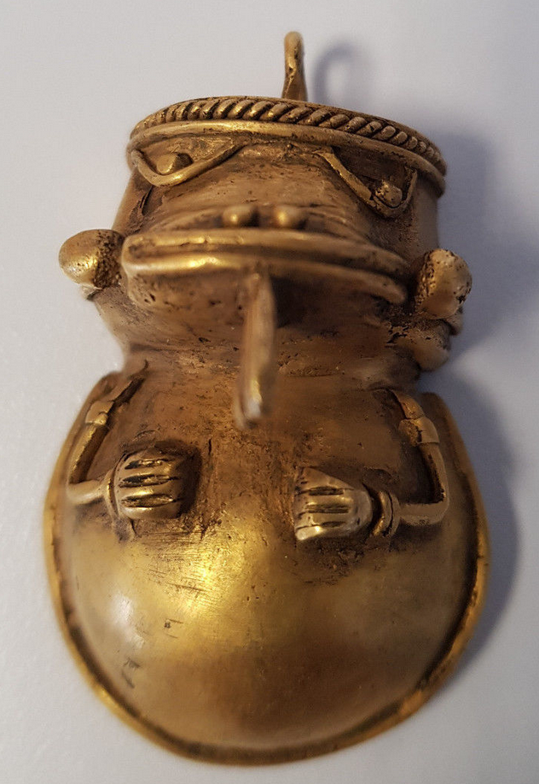 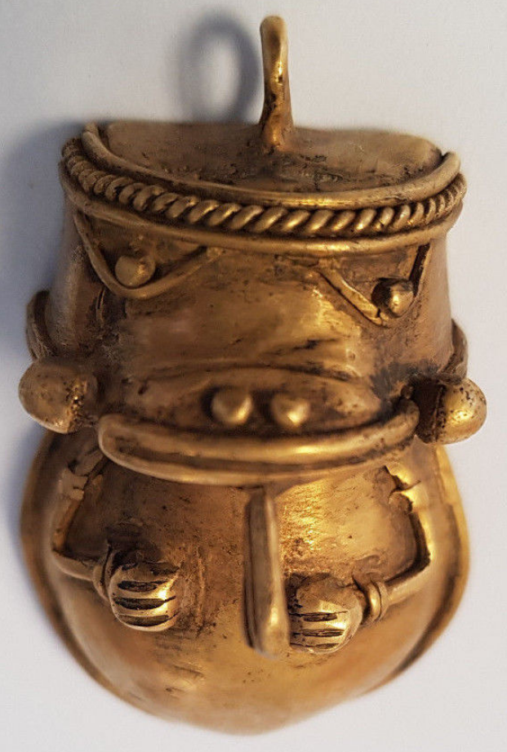

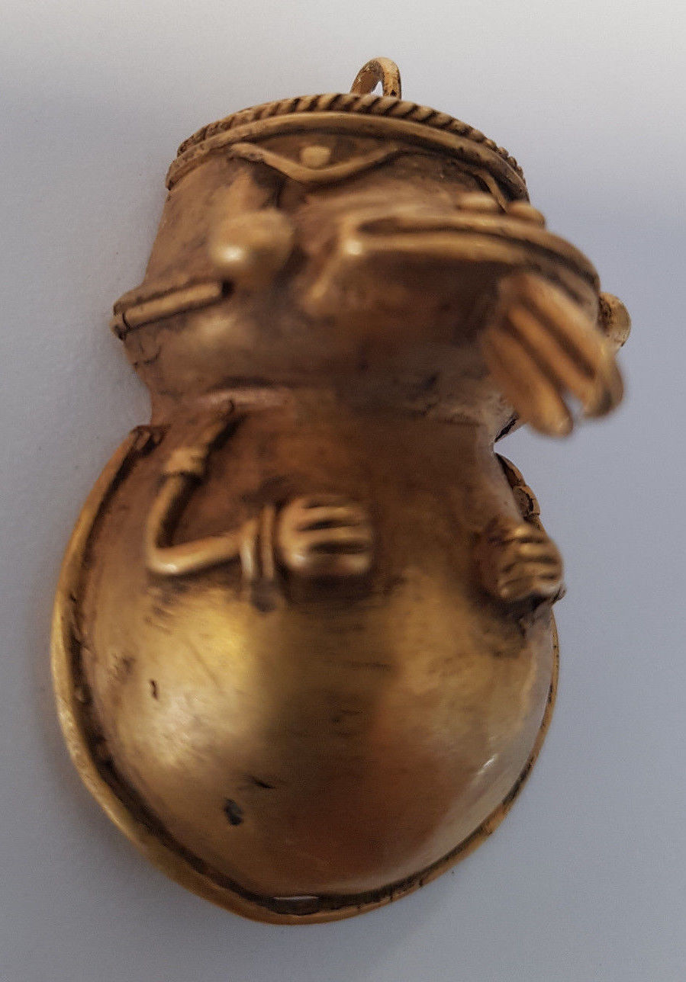 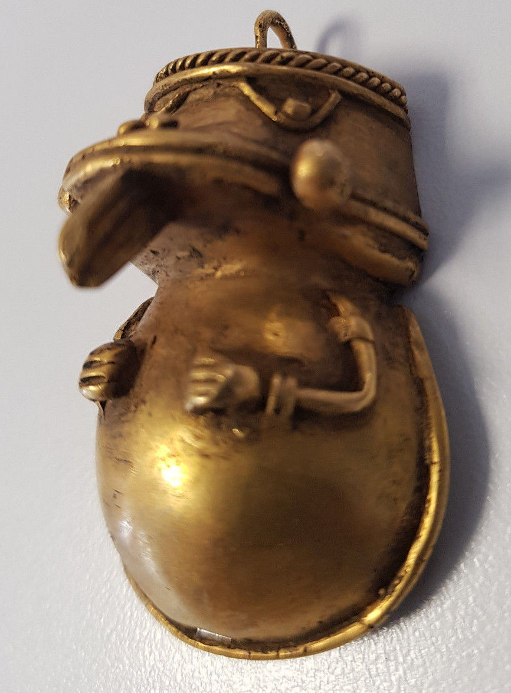

Figs. 1-4. Colombia-Sierra Nevada de Santa Marta-Tairona-Pendant-Shaman-Tumbaga-1000-1500 CE

**Case no.: 7**

**Accession Number:**

**Formal Label:** Colombia-Sierra Nevada de Santa Marta-Tairona-Pendant-Shaman-Tumbaga-1000-1500 CE **Display Description:**

Pre-Colombian Tairona shaman in the process of changing into his spiritual animal. This figure was produced using the authentic lost wax casting with tumbaga, an alloy of gold/copper/silver. This figure is from north-east Colombia in the Sierra Nevada de Santa Marta. It was made by the Tairona indigenous people 1000-1500 CE.

**LC Classification:** F1434.2

**Date or Time Horizon:** 1000-1500 CE

**Geographical Area:** Sierra Nevada de Santa Marta**,** Colombia. Indigenous peoples names are:Kankuamo (*Umunukunu)* and Kogi (*Gonawindua).*

**GPS Coordinates:** **10o57’N, 73 o 48’W**



Fig. 5. Map of Spanish Provinces in 1600. After <https://html2-f.scribdassets.com/5nmwqq7itc4aqx2e/images/6-a5a093175f.jpg>. Yellow place-holders mark the centers of the four Tairona cultures (in bold) as of 2017.

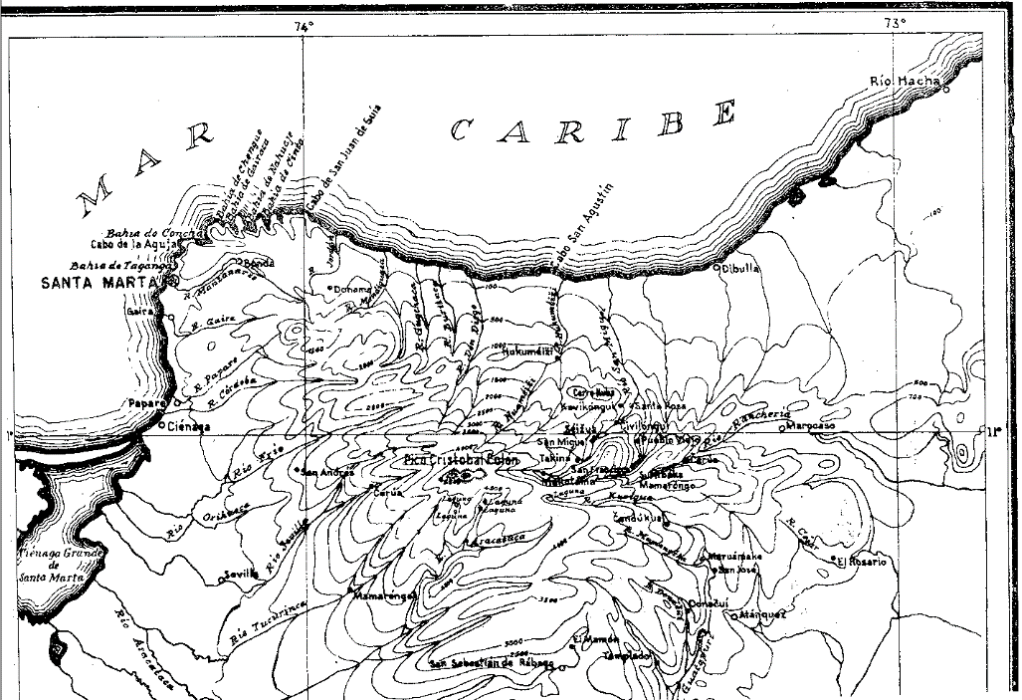

Fig. 6. Topographic map of the Sierra Nevada of NE Colombia. From Reichel-Dolmatoff 1950.

**Cultural Affiliation:** Tairona, Chibcha Language.

The name "Tairona" was derived by Konrad Preuss from a Tairona word *térú*, meaning "older brother" (Preuss, 1926: 43). Reichel-Dolmatoff associates the name with *teirúna* or *terún*a meaning in the Kogi and Ica language "people, progenitors" (Reichel-Dolmatoff 1953a). The Chibcha language attribution is inconclusive.

**Medium:** Lost-wax cast of tumbaga, an alloy of gold and copper. Its surface was subsequently enriched by the depletion method, also known as *mise-en-couleur*.

**Dimensions:** W 2.0 in, H 1.2 in

**Weight:** 19.9 gr

**Condition: original**

**Provenance:**

All our tumbagas are legally exported, and under the laws of Colombia and United States of America, this does not represent any harm to the Colombian patrimonium.-

**Discussion:**

Tairona spirituality in its Kogi version is based on *aluna*, cosmic harmony. The central figure of Kogi religion is the Universal Mother or Gaulcováng (from gau – “to create”), is the creator at the beginning of time of the “Cosmic Egg” that encompasses the universe. The Universal Mother, has many manifestations, such as **Hába Guxsénse**, “Mother of the Eternal Fire,” and Málkwa-yang, “Mother of the Knowledge of Weaving.” (Reichel-Dolmatoff 1975; 1985; 1987; 1990). The Kogi Cosmic Egg is composed of nine worlds that correspond to the nine months of human gestation (Tairona 2015).

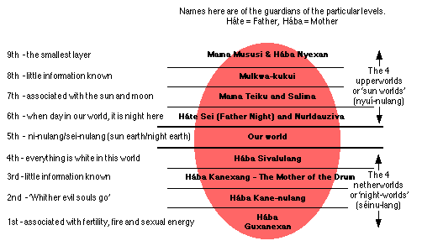

Fig. 7. Structure of the Kogi Cosmic Egg. Based on Reichel-Dolmatoff 1978, from Tairona 2015.

This egg-shaped universe has nine superimposed levels, and humankind occupies the middle one of these. The four upper levels (nyui-nulang, sun worlds) each have their own suns. The sun of the third level is Teiku, who lives there with his “family” of celestial beings, planets, and constellations. The principal divinities are the Universal Mother’s sons—Seokukui, Seizankwa, Kuncavitabueya, Aldauhuiku, and Mulkuexe who balance the Cosmic Egg on their lances that are carried on their shoulders. These two lances are symbolized architecturally in the Kogi domiciles and can be seen protruding from the roofs.

Tairona spirituality in its Arhuaco version is based on *Kunsamü*, a sacred, pre-existent, universal law that aims to preserve equilibrium and harmony among all things. The father-creator Kakü Serankua, in the beginning, molded Chundúa in Iku, the language of the Arhuacos, the highest snow-covered peak (named by the Spanish “Pico de Cristobal Colon” to de-sacralize it) of the central massif (named by the Spanish “Sierra Nevada de Santa Marta” to re-sacralize it) Umunukunu in Iku. Umunukunu is thought to be the “Heart of the World” and the “Origin of Life”. Kakü Serankua also created the first gods, and the first men -- the Elder Brothers – the Taironas -- and bestowed upon them the duty of protecting the earth. The Umunukunu are akin to their bodies, with the highest peak corresponding to their head, the lagoons and lakes below to their heart, the rivers and streams to their veins, the layers of soil to their muscles, and the scrublands to their hair.

Combining the spirituality of the Kogi and the Arhuaco we can see that a duality is implied by their common ancestor, the Tairona, in which there was probably both a Mother Creator and a Father Creator. Duality may be seen in many of the gold artifacts of the Tairona suggesting a complex interweaving of complimentary ideas and visual themes

**References**

Adelaar, Willem F. H. and Pieter Muysken. 2004.  *The Languages of the Andes*. Cambridge: [Cambridge University Press](https://en.wikipedia.org/wiki/Cambridge_University_Press).

Bischof, Henning. 1961. “News Report,” *Katunob* 2, 3: 41-45.

1968a. “Contribuciones a la cronología de la Cultura Tairona, Sierra Nevada de Santa Marta.” In *Proceeedings of the 38th International Congress of Americanists*, pp. 259-269. Stuttgart.

1968b. “La Cultura Tairona en el Area Intermedia.” In *Proceedings of the 38th International Congress of Americanists*, pp. 271-280. Stuttgart.

1971. “Die Spanisch-Indianische Auseinandersetzung in Der Nördlichen Sierra Nevada De Santa Marta (1501-1600)”. Bonner amerikanistische Studien 1. Bonn. PhD Dissertation

1972. “Una coleccion etnografica de la Sierra Nevada de Santa Marta (Colombia) – Siglo XVII,” *Atti XL Congresso Internationale degli Americanisti*. Roma-Genova, pp. 391-398.

1983. “Indígenas y españoles en la Sierra Nevada de Santa Marta, siglo XVI,” *Revista Colombiana de Antropología* 24: 75-124.

Bocarejo Suescun, Diana. 2001. “Fragmentos etnográficos y objetos prehispánicos: representando lo indígena en el Museo del Oro,” *Revista de Arqueología del Area Intermedia* 3: 151-182.

2002. “Indigenizando ‘lo blanco’: conversaciones con arhuacos y kogis de la Sierra Nevada de Santa Marta,” *Revista de Antropología y Arqueología* 13: 3-44.

2008. “Reconfiguring the political landscape after the multicultural turn.” Unpublished PhD Dissertation, Chicago: University of Chicago.

Bray, W. 2003. “Gold, Stone, and Ideology: Symbols of Power in the Tairona Tradition of Northern Colombia.” In: Quilter J., J. W. Hoopes (eds.), *Gold and Power in Ancient Costa Rica, Panama, and Colombia*. (Washington: Dumbarton Oaks Pre-Columbian Conference Proceedings), pp. 301- 344.

Cadavid, Gilberto. 1987. Proyecto de preservación de Pueblito. Informe de actividades. Junio - noviembre de 1987. Instituto Colombiano de Antropología – FIAN. Unpublished Report

1988. “Proyecto de preservación de Pueblito. Informe de actividades. Agosto de 1988.” Instituto Colombiano de Antropología – FIAN. Unpublished Report.

1993 Proyecto de preservación y restauración de Pueblito. Parque Nacional Natural Tayrona. Informe de actividades. Septiembre - diciembre de 1993. Instituto Colombiano de Antropología – FIAN. Unpublished Report.

n.d. Excavación arqueológica de un basurero en Buritaca 200 (Ciudad Perdida)-Frente Occidental Bajo, Informe Preliminar Temporada 1983. ICAN, 6 vols. Unpublished Report.

Cadavid, Gilberto and Ana María Groot. 1987. Buritaca 200 Arqueología y conservación de una población precolombina. Boletín del Museo del Oro 19: 57-82. Cadavid, Gilberto and Luisa F. Herrera. 1985. Manifestaciones Culturales en el Area Tairona. Informes Antropológicos 1: 5-54.

Cardoso P.1987. “Uso y significado de las cuentas tairona,” *Boletín del Museo del Oro*, 19: 117-123.

Coleridge, Samuel Taylor. 1950. *The philosophical lectures hitherto unpublished*. Ed. K. Coburn. London: Routledge and Kegan Paul.

D'Anghiera, Peter Martyr. 1555. De Orbo Novo. Trans. Richard Eden as The decades of the newe worlde or west India conteynyng the nauigations and conquestes of the Spanyardes with the particular description of the moste ryche and large landes and Ilands lately founde in the west Ocean perteynyng to the inheritaunce of the kinges of Spayne, Book III, §3. London: William Powell.

[EÑES](https://translate.googleusercontent.com/translate_c?depth=1&hl=en&prev=search&rurl=translate.google.com&sl=es&sp=nmt4&u=https://medium.com/somos-enes%3Fsource%3Dfooter_card&usg=ALkJrhhV4slgnlp8CrzVzf2wyo-CDNCwag). 2017. *La Biblioteca como protectora del mundo*. https://about.me/souldes.

Ereira, Alan. 1993. [The Elder Brothers](http://www.amazon.com/Elder-Brothers-Alan-Ereira/dp/0679743367/ref=tmm_pap_swatch_0?_encoding=UTF8&sr=&qid=). New York: Vintage Books.

Falchetti A.M. 1987. “Desarrollo de la orfebrería Tairona en la provincia metalúrgica del norte

Colombiano,” *Boletín del Museo del Oro*, 19: 3-23.

Fabré, Alain. 2005. [*Diccionario etnolingüístico*](http://www.ling.fi/Entradas%20diccionario/Dic=Chibcha.pdf) y guía bibliográfica de los pueblos indígenas sudamericanos. Internet Electronic File.

Frank, Paul S. 1992. “Reconstrucción de las variaciones en Proto-Aruaco,” *Thesaurus (*Bogotá)47: 532-542.

1993. “Proto-Arhuacan phonology,” *Estudios de Lingüística Chibcha,* 12: 95-117.

González-Plazas, Santiago. 2008. *Pasado y presente del contraband en La Guajira aproximaciones al fenómeno de ilegalidad en la region.* Bogotá: Centro de Estudios y Observatorio de Drogas y Delito Facultad de Economía, Universidad del Rosario.

Gutierrez Hinojosa, Tomas Dario. 2000. Valledupar Musica de una Historia. Bogota: Editorial Grijalbo LTDA.

Hammarström, Harald; Forkel, Robert; Haspelmath, Martin; Bank, Sebastian, eds. 2016. [*"Kankuamo"*](http://glottolog.org/resource/languoid/id/kank1244). [*Glottolog 2.7*](https://en.wikipedia.org/wiki/Glottolog). Jena: Max Planck Institute for the Science of Human History.

Joshua Project, 2017: <https://joshuaproject.net/people_groups/13448/CO>

Langebaek, Carl. 1987. “La cronologia de la región arqueológica tairona vista desde Papare, Municipio de Ciénaga,” *Boletín de Arqueología* 2, 1: 85-104.

2003. “The Political Economy of Pre-Colombian Goldwork: Four Examples from Northern South America.” In *Gold and Power in Ancient Costa Rica, Panama and Colombia*, Jeffrey Quilter and John W. Hoopes, Eds. 245-278. Washington D.C: Dumbarton Oaks.

2005. *The Prehispanic Populations of the Santa Marta Bays*. Bogota and Pittsburgh: University of Pittsburgh.

Langebaek, C. 2007. “La idolatría de los indios en el siglo xvii: El caso de los arhuacos.” In *Indios y españoles en la antigua Provincia de Santa Marta, Colombia: Documentos de los siglos XVI y XVII*. Universidad de los Andes, Colombia, pp. 221-248.

Legast, A. 1982. “La fauna mítica Tairona,” *Boletín del Museo del Oro*, 13:1-18

1987 El animal en el mundo mitico Tairona. Fundación de Investigaciones Arqueológicas Nacionales. Banco de la República; Bogotá.

Legast, A. and A. Cadena. 1986. “El murcielago en el material arqueologico, colombiano,” *Boletín de arqueología*, 1(3): 25-34.

Looper, Matthew. 2003. “From inscribed bodies to distributed persons: contextualizing Tairona figural images in performance,” *Cambridge Archaeological Journal* 13, 1: 25-40.

Mason, J. Alden. 1931. *Archaeology of Santa Marta, Colombia. The Tairona Culture*. Field Museum of Natural History, Anthropological Series, Vol. 20 (No. 1), Part I, Report on Field Work. Chicago: Field Museum Press. –

1936. *Archaeology of Santa Marta, Colombia. The Tairona Culture*. Field Museum of Natural History Anthropological Series, Vol. 20 (No. 2), Part II, Section I, Objects of Stone, Shell, Bone and Metal. Chicago: Field Museum Press.

1939. *Archaeology of Santa Marta, Colombia. The Tairona Culture*. Field Museum of Natural History, Anthropological Series, Vol. 20 (No. 3), Part II, Section II, Objects of Pottery. Chicago: Field Museum of Natural History.

National Institutes of Health; Committee to Review the Health Effects in Vietnam Veterans of Exposure to Herbicides. 1994. [*Veterans and Agent Orange: Health Effects of Herbicides Used in Vietnam*](https://books.google.com/books?id=2YQTHJlt5l4C&pg=PA90). Washington: National Academies Press.

Nicholas, Francis G. 1901. “The Aborigines of the Province of Santa Marta, Colombia,” *American Anthropologist* (New Series) 3, 4: 606-649.

Oyuela-Caycedo, A. 1986. “De los Tairona a los Kogi: Una interpretación del Cambio Cultural,” *Boletín del Museo del Oro*, 17: 32-43

2005. “El surgimiento de la rutinización religiosa: los orígenes de los tairona-kogis.” In Chaumeil J.P., R.P. Camacho and J.F. Bouchard (eds.), *Chamanismo y sacrificio, Persectivas arqueológicas en sociedades indígenas de América del  Sud*. Bogotá, pp. 141-163

2010. “The Forest as a Fragmented Archaeological Artifact.” In Dean R.M. (ed.), *The Archaeology of Anthropogenic Environments*. Carbondale: University of Michigan Press, pp.75-94.

Panoramas. 2015. <http://www.viewfinderpanoramas.org/panoramas.html#longlines>

Plazas, C. 1987. “Forma y fución en el oro Tairona,” *Boletín del Museo del Oro*, 19: 25-33.

Preuss, Konrad Theodor. 1993 [1926]. *Visita a Los Indígenas Kágaba De La Sierra Nevada De Santa Marta: Observaciones, Recopilación De Textos Y Estudios Lingüísticos.* Santafé de Bogotá: Instituto Colombiano de Antropología.

Rajput, D. S., R. S. and G. S. Thakur, and Neeraj Sahu. 2012. “Analysis of Social Networking Sites

Using K- Mean Clustering Algorithm, *International Journal of Computer & Communication Technology*, 3: 88-92.

Réclus, Élisée. 1875-94. La Nouvelle Géographie universelle, la terre et les hommes, 19 vol. Paris.

Reichel-Dalmatoff, Gerardo.1942. "Apuntes arqueológicos de Soacha," *Revista del Instituto Etnológico Naccional*, pp. 15-25.

1953a. “Contactos y cambios culturales en la Sierra Nevada de Santa Marta,” *Revista Colombiana de Antropología* 1(1): 15-122.

1953b. “Investigaciones arqueológicas en el departamento del Magdalena: 1946-1950. Parte III: arqueología del bajo Magdalena.” *Divulgaciones Etnológicas* 4(4): 1-96 + 23 láminas. Barranquilla: Instituto Etnológico del Atlántico.

1954a. “Investigaciones Arqueológicas en la Sierra Nevada de Santa Marta. Partes 1-2,” *Revista Colombiana de Antropología,* 2(2): 147-206.

1954b. “Investigaciones Arqueológicas en la Sierra Nevada de Santa Marta. Parte 3,” *Revista Colombiana de Antropología,* 3(3): 141-170.  
  
1959. “La Mesa. Un complejo arqueológico de la Sierra Nevada de Santa Marta,” *Revista Colombiana de Antropología,* 8: 159-214.

1963. “Investigaciones arqueológicas en la Costa Pacífica de Colombia II- Una secuencia cultural del Bajo Río San Juan,” *Revista Colombiana de Antropología,* 2: 9-81.

1990. “The Sacred Mountain of Colombia’s Kogi Indians,” *Iconography of Religions*, sec. 9, South America, fasc.2, Serie M. Leiden.

1997. *Arqueología de Colombia: Un texto introductorio* (1986)*.* Bogotá: Imprenta Nacional de Colombia.

Reichel-Dalmatoff, Gerardo and Alicia Dussan de Reichel. 1942. "Las urnas funerarias en la cuenca del río Magdalena", *Revista del Instituto Etnológico Nacional*, Bogotá, pp. 109-160.

1951. “Investigaciones arqueológicas en el departamento del Magdalena: 1946-1950”. Parte I: “Arqueología del río Ranchería; Parte II: “Arqueología del río Cesar”. *Boletín de Arqueología,* III(1-6): 1-334. Bogotá: Instituto Etnológico Nacional.

1955. “Investigaciones arqueológicas en la Sierra Nevada de Santa Marta. Parte IV: sitios de habitación del período Tairona II, en Pueblito,” *Revista Colombiana de Antropología,* 4: 189-245.

1961. "Investigaciones arqueológicas en la costa Pacífica de Colombia :I - El sitio de Cupica" *Revista colombiana de antropología,* Bogotá. 10: 237-317.

1987. “Arquitectura y Urbanismo en la Cultura Tairona,” *Boletín del Museo del Oro,* 19: 87-96.

Sievers, Wilhelm. 1986. “Die Arhuaco-Indianer in der Sierra Nevada de Santa Marta,” Zeitschrift der Gesellschaft fuer Erdkunde, 21: 388-400.

SIL International et al. 2005. *Ethnologue: Languages of the World*. Dallas, Texas: SIL International.

Simons, F.A.A. 1879. “Notes on the Topography of the Sierra Nevada de Santa Marta,” *Proceedings of the Royal Geographical Society and Monthly Record of Geography* 1, 11 (Nov): 689-694.

1881. “On the Sierra Nevada de Santa Marta and Its Watershed (State of Magdalena, U.S. of Colombia),” *Proceedings of the Royal Geographical Society and Monthly Record of Geography* 3, 12 (Dec): 705-723.

Tairona. 2015. <http://tairona.myzen.co.uk/>).

Uribe Tobon, Carlos Alberto. 1990. “We, the Elder Brothers: Continuity and change among the Kággabba of the Sierra Nevada de Santa Marta, Colombia.” Unpublished PhD dissertation, Pittsburgh, University of Pittsburgh.

1996. “Destrucción de templos indígenas en la Sierra Nevada de Santa Marta: siglo XVII,” Boletín del Museo del Oro 40: 17-36.

Vinalesa, José de. 1952. *Los indios arhuacos de la Sierra Nevada de Santa Marta*. RIEN. Bogotá: Editorial Iqueima.